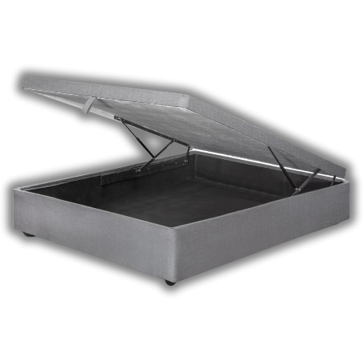


Model : Storage Base - Standard
Manufacturer : Mattress World
Features :
- Heavy Duty 7 Slat Design
- Cup Legs
- Textile Fabric
- 120kg Per Person Per Side
Prices Standard Length :
- Single – R2799
- Three Quarter – R2999
- Double – R3299
- Queen – R3499
- King (2 x Singles) – R5598
Prices Extra Length :
- Single – R3359
- Three Quarter – R3599
- Double – R3959
- Queen – R4199
- King (2 x Singles) – R6718

